LORD’S PRAYER
P Gathered into one by the Holy Spirit, let us pray as Jesus taught us.
C Our Father, who art in heaven, hallowed be thy name,
thy kingdom come, thy will be done,
on earth as it is in heaven.
Give us this day our daily bread; and forgive us our
trespasses, as we forgive those who trespass against us;
and lead us not into temptation, but deliver us from evil.
For thine is the kingdom, and the power, and the glory,
forever and ever. Amen.

BLESSING
P God, the beginning and the end,
who has written your name in the book of life,
☩ bless and keep you in grace and peace
from this time forth and forevermore.
C Amen.

CLOSING HYMN (see insert)

DISMISSAL
P Led on by the saints before us, go in peace to serve the Lord.
C Thanks be to God.

POSTLUDE

From sundaysandseasons.com.
License #SB123685
Copyright © 2021 Augsburg Fortress. All rights reserved.

historic

Upper Tinicum Evangelical Lutheran Church

188 Upper Tinicum Church Road

PO Box 166

Upper Black Eddy, PA

(610) 294-9391

http://facebook.com/uppertinicumlc
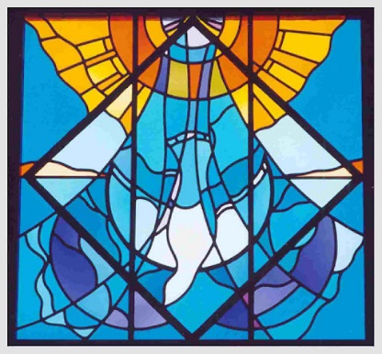

• God himself will be with them •

• Death will be no more •

All Saints Sunday
November 6, 2022 ~ 10:00 am

Serving Christ & the Upper Tinicum
Community for over 100 years

☩ ☩ ☩

Deacon Kathleen Afflerbach

Corey Olver, Guest Organist

WELCOME – Greetings to everyone present & at home
CONFESSION AND FORGIVENESS
All may make the sign of the cross, the sign marked at baptism.
P Blessed be the holy Trinity, ☩ one God,
who redeems us in Christ Jesus,
whose steadfast love endures forever.
C Amen.
P Let us confess our sin in the presence of God and of one another.
Silence is kept for reflection.
P Most merciful God,
C We confess that we have sinned against you
and our neighbors. We have ignored voices
that call for your justice.
We have neglected actions that witness to your righteousness.
We have spoken and acted
in ways that disrupt your beloved community.
We truly repent of things we have done and left undone.
For the sake of Jesus Christ, have mercy on us.
Restore our troubled spirits, so that we may live in newness,
follow the way of the Spirit,
and build up the body of Christ.
Amen.
P Rejoice and be glad!
God hears the prayers of all who cry out,
and restores us to life through the death
and resurrection of Jesus Christ.
Therefore, I declare to you the forgiveness of all your sins,
in the name of the Father,
and of the ☩ Son,
and of the Holy Spirit.
C Amen.

OPENING HYMN (see insert)

GREETING
P The grace of our Lord Jesus Christ, the love of God,
and the communion of the Holy Spirit be with you all.
C And also with you.

PRAYER OF THE DAY
P Let us pray, (see insert)
C Amen.

FIRST READING (see insert)
L Word of God. Word of life.
C Thanks be to God.

PSALM Read responsively (see insert)

SECOND READING (see insert)
L Word of God. Word of life.
C Thanks be to God.
GOSPEL (see insert)
P The Holy Gospel according to St. ___ the ___ chapter.
C Glory to you O Lord. (The Gospel is read)
P The gospel of the Lord.
C Praise to you O Christ.

THE MEDITATION – Deacon Kathy Afflerbach

HYMN OF THE DAY (see insert)

APOSTLES CREED
C I believe in God, the Father almighty, creator of
heaven and earth.

I believe in Jesus Christ, his only Son, our Lord.
He was conceived by the power of the Holy Spirit and
born of the virgin Mary. He suffered under Pontius Pilate,
was crucified, died, and was buried.
He descended into hell. On the third day he rose
again. He ascended into heaven, and is seated at
the right hand of the Father. He will come again to
judge the living and the dead.

I believe in the Holy Spirit, the holy catholic Church,
the communion of saints, the forgiveness of sins, the
resurrection of the body, and the life everlasting. Amen
CANDLELIGHTING CEREMONY

PRAYERS OF INTERCESSION (see insert)

SHARING THE PEACE
P The peace of Christ be with you always.
C And also with you.
Please greet each other with a distanced sign of Christ’s peace.

OFFERING PRAYER
P Blessed are you, Maker of all things.
As you have entrusted us with all that you have created,
now gather our gifts, nourish us with this sacrament,
and send us to those who hunger and thirst,
for the sake of Jesus Christ our Savior.
C Amen.

